Software Requirements Specification

Version 3.0

25/03/2016

Infrastructure Management System

Submitted in partial fulfillment

Of the requirements of

CS 223 Software Engineering

This work is based upon the submissions of the course Software Engineering (CS223). The students who submitted this team projects are:

1. Anjali Malav (ug201310006).
2. Bharti Gothwal (ug201310011).
3. Bharti Arya (ug201310012).

**Version History:**

|  |  |
| --- | --- |
| **Version 1.0** | 1. Only use case diagrams. 2. Required re-definition of assets. |
| **Version 2.0** | 1. Class diagram, sequence diagram and activity diagram of all use cases are added. 2. A new use case “generating complain ID” has been added. 3. Re-definition of assets. |
| **Version 3.0** | 1. All the UML diagrams has been revised according to the software. |

# Table of Contents

Table of Contents i

List of Figures ii

1.0. Introduction 1

1.1. Purpose 1

1.2. Scope of Project 1

1.3 Constraints 1

1.4 Assumptions and Dependencies 1

1.3. Glossary 2

1.4. References 2

1.5. Overview of Document 2

2.0. Overall Description 3

2.1 System Environment 3

2.2 Functional Requirements Specification 3

2.3 User Characteristics 8

2.4 Non-Functional Requirements 8

3.0. Requirements Specification 9

3.1 Functional Requirements 9

3.1.1 << Name of the first feature>> 9

3.1.2 << Name of the second feature>> 9

3.3 Detailed Non-Functional Requirements 11

***3.4*** ***Logical Structure of the Data*** 11

4.0 Supporting information 11

4.1 Table of contents and index 11

4.2 Appendixes 11

# List of Figures

|  |  |
| --- | --- |
| Name of UML | Page No. |
| 1)Use case diagram of system | 4 |
| 2)Class diagram of system | 5 |
| 3)Sequence diagram of login | 5 |
| 4) Sequence diagram of select complain | 6 |
| 5) Sequence diagram of submit complain | 6 |
| 6) Sequence diagram of check databse | 6 |
| 7) Sequence diagram of update database | 7 |
| 8)Activity diagram of system | 7 |

# 1.0. Introduction

## 1.1. Purpose

The purpose of this document is to make the complaint procedure related to infrastructure easier, faster and reliable. It will help to keep the documentation of all the complaints related to infrastructure.

## 1.2. Scope of Project

This software is designed for two kinds of users:

1. **End User**
2. **Employee**
3. End User: It can be anyone who is registered in the institute with LDAP credentials. This person can file the complaint.
4. Employee: This person will manage the complaint software by assigning the workers. This person requires special credentials.

## 1.3 Constraints

The unauthorized users will not be able to file the complaint.

## 1.4 Assumptions and Dependencies

1) All the rooms of hostels are having required assets and in working conditions.

2) Database related to infrastructure assets is documented.

3) Set of workers required for the infrastructure jobs are available.

4) Employees who will operate the software are available.

## 1.3. Glossary

|  |  |
| --- | --- |
| **Term** | **Definition** |
| End users | The people accessing the services. |
| Employee | The person who operates the software and provides service. |
| Worker | The person who will solve the problems like plumber, carpenter, cleaner and electrician. |
| Valid problems | Problems related to infrastructure only. |
| Invalid problems | Problems not related to infrastructure like taking leave, mess food is not good etc. |
| Assets | Property of infrastructure:   1. Chairs 2. Tables 3. Fan 4. Tube light 5. Geyser 6. Tap 7. Switch Board 8. Water Supply 9. Water Cooler 10. Cleaning 11. Paint 12. Mosquito Repellant 13. Door 14. Window |

## 1.4. References

IEEE. *IEEE Std 830-1998 IEEE Recommended Practice for Software Requirements Specifications.* IEEE Computer Society, 1998.

## 1.5. Overview of Document

The rest of the document is designed in the following way:

# 2.0. Overall Description

## 2.1 System Environment

* Backend: PHP
* Database: MYSQL
* Frontend: HTML, CSS
* Local server : Wamp server

## 2.2 Functional Requirements Specification

* phpMyAdmin
* Browser

**2.2.1 Use case diagram** 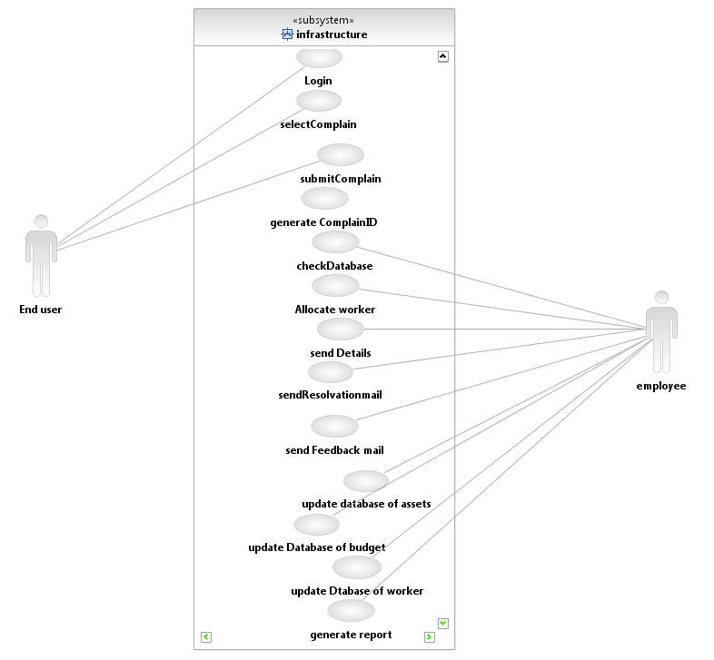

**2.2.2 Class Diagram**

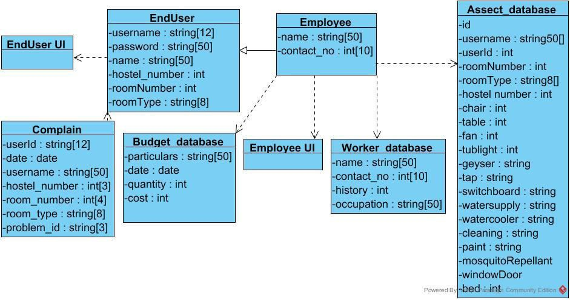

**2.2.3 Sequence Diagrams**

2.2.3.1) Login

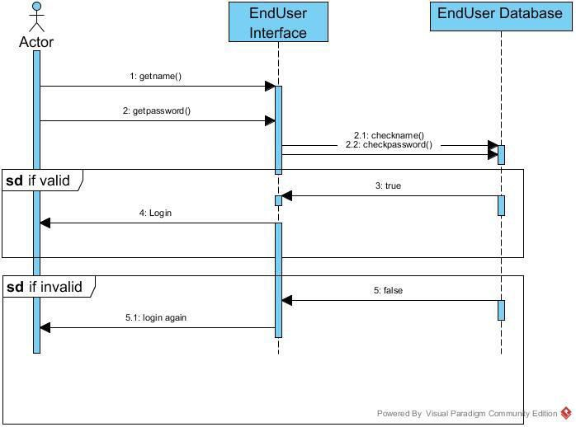

* + - 1. Select Complain

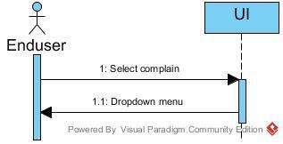

* + - 1. Submit Complain

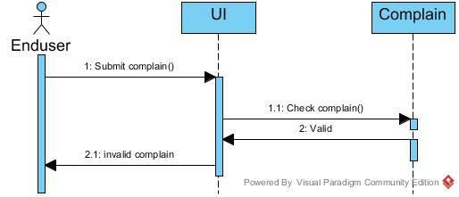

* + - 1. Check Database

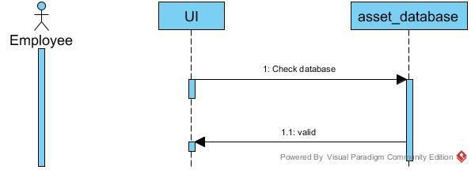

**2.2.4 Activity diagram**

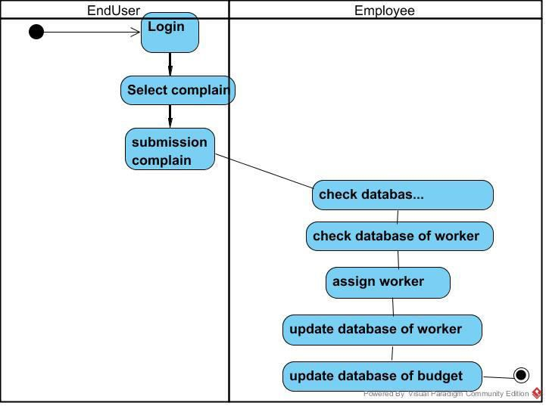

.

## 2.3 User Characteristics

* User must be able to handle a computer. Basic knowledge of computer is required.
* He must have clear idea of his roles.
* He must be familiar with software where a person has to enter username and password to get access of information.

## 2.4 Non-Functional Requirements

Product Requirement.

Organizational Requirement.

3.0. Requirements Specification

## 3.1 Functional Requirements

### 3.1.1 Login

|  |  |
| --- | --- |
| **Use Case Name** | Login |
| **Trigger** | Start System |
| **Precondition** | You must be registered on LDAP. |
| **Basic Path** | 1. Enter the credentials 2. You will be login. |
| **Alternative Paths** | - |
| **Post condition** | Successfully login. |
| **Exception Paths** | 1. If details are invalid. 2. Enter again |
| **Other** | - |

### 3.1.2 Selection of complains

|  |  |
| --- | --- |
| **Use Case Name** | Selection of complain |
| **Trigger** | Login to the software |
| **Precondition** | Login credentials should be valid and registered |
| **Basic Path** | 1. Login. 2. Selecting the complains |
| **Alternative Paths** | - |
| **Post condition** | Selection of desired complain |
| **Exception Paths** | - |
| **Other** |  |

### 3.1.3 Submitting the complains

|  |  |
| --- | --- |
| **Use Case Name** | Submitting the complain |
| **Trigger** | Selection of complain |
| **Precondition** | Complaint box should be filled. |
| **Basic Path** | 1)Login.  2)Selection of complain.  3)Submission of complain. |
| **Alternative Paths** | - |
| **Post-condition** | Complaint submitted successfully. |
| **Exception Paths** | - |
| **Other** | No successful submission if the complaint-box is empty |

3.1.4 Check database

|  |  |
| --- | --- |
| **Use Case Name** | Check database |
| **Trigger** | Received the complaint |
| **Precondition** | Complaint should be submitted successfully |
| **Basic Path** | 1. Submission of complain. 2. Receiving the complaint. |
| **Alternative Paths** | - |
| **Post-condition** | Complaint submitted successfully. |
| **Exception Paths** | - |
| **Other** | - |

3.1.5 Allocate the worker

|  |  |
| --- | --- |
| **Use Case Name** | Allocate the worker |
| **Trigger** | Received complaint |
| **Precondition** | At least the desired worker should be free. |
| **Basic Path** | 1. Receiving the complaint. 2. Contact the worker. 3. Allocate the worker. |
| **Alternative Paths** | - |
| **Post-condition** | Worker has been allotted. |
| **Exception Paths** | - |
| **Other** | - |

### 

3.1.7 Update the database of worker

|  |  |
| --- | --- |
| **Use Case Name** | Update the database of worker |
| **Trigger** | Allocation of worker. |
| **Precondition** | The worker has done the job. |
| **Basic Path** | 1. Worker allocated. 2. Worker completed the job successfully. |
| **Alternative Paths** | - |
| **Post-condition** | Changes has been made in database. |
| **Exception Paths** | - |

## 3.3 Detailed Non-Functional Requirements

Product Requirement: This software will be operated during 6.00am-11.59pm except national holidays.

Organizational Requirement: Users of this software shall authenticate by using LDAP credentials.

### ***3.4 Logical Structure of the Data***

<< Keep this blank for the time being>>

# 4.0 Supporting information

## 4.1 Table of contents and index

## 4.2 Appendixes